**King’s Business School, King’s College London**

**Cover Sheet for [7QQMM906] 25/26**

|  |  |
| --- | --- |
| **Candidate ID:** | **AG37642, AG 33419** |
| **Module Code:** | **7QQMM906** |
| **Module Name:** | **Environmental Economics** |
| **Word Count:** | **2163 words (excluding Cover Sheet [229], Abstract [191], Bibliography [217] and Appendix [33] – adding up to 665 words); therefore roughly 10% over the word limit** |

**Submitted: 17th of December 2025**

DECLARATION BY STUDENTS

We understand what is meant by plagiarism/collusion and have signed at enrolment the declaration concerning the avoidance of plagiarism/collusion.

I understand that plagiarism and collusion is a serious examinations offence that may result in disciplinary action being taken.

I understand that I must submit work BEFORE the deadline, and that failure to do so may result in late submission penalties.

I understand that where a word limit is indicated, I should adhere to the word limit and failure to do so may result in penalties.

I understand that King's requires students to acknowledge any use of generative AI tools in coursework.

Please delete one of the statements below and attach this document to your assignment before uploading:

1. I declare that no part of this submission has been generated by AI software. These are my own words.

Note. Using software for English grammar and spell checking is consistent with Statement 1.

By completing this assessment, you acknowledge that you have read and understand the above. Please do not sign your name.

**Abstract**

Population growth in metropolitan areas has been proven to increase traffic congestion and air pollution. A widely used instrument attempting to mitigate Greenhouse Gas (GHG) emissions are Low Emission Zones (LEZ). London’s Ultra Low Emission Zone (ULEZ), introduced in 2019 and expanded in 2021 and 2023, is the strictest LEZ worldwide, as it operates 24 hours a day (except for the 25th of December) and charges vehicles that do not comply a daily fee of £12.50. While some studies identify a significant decrease in NOx and PM emissions since the initial implementation of London’s ULEZ, others find a minimal impact on NO2 emissions, suggesting that LEZs alone are insufficient in mitigating GHG. This report expands previous studies by using satellite-based data and utilising randomised control groups instead of similar UK cities, therefore assessing column density across different site types. This report shifts the focus on spillover effects and policy by-products, proving insights for future policies. We found a significant effect of the policy’s 2nd expansion and observe a spillover effect on suburban and roadside site types. This suggests a move away from island policies to cooperational policies with adjacent areas.

**Contents**

[**1. Part I: Motivation & Data Context 5**](#_Toc26574)

[a. Dataset Selection 5](#_Toc7878)

[Chosen Databases: 5](#_Toc28721)

[1. Sentinel-5P OFFL NO2 5](#_Toc747)

[2. ERA5 Land Hourly – ECMWF Climate Reanalysis 6](#_Toc14333)

[b. Research Questions 6](#_Toc2679)

[c. Data Significance and Relevance 7](#_Toc20902)

[**2. Part II: Technical Implementation 7**](#_Toc17714)

[a. Coding Setup and Documentation 7](#_Toc16495)

[b. Data Preparation and Management 8](#_Toc31112)

[b-1 Cleaning processes 8](#_Toc2177)

[1) Generate variables 8](#_Toc15549)

[2) Handle missing values, outliers, and inconsistencies 9](#_Toc3269)

[3) Problems and solutions 9](#_Toc26086)

[b-2 Data aggregation: 10](#_Toc4232)

[b-3 Data merging 10](#_Toc31105)

[b-4 Variable transformation: 11](#_Toc9004)

[**3. Part III: Descriptive Analysis and Export of Results 11**](#_Toc23258)

[**4. Part IV: Discussion and Conclusions 27**](#_Toc11891)

[a. Key Findings Summary 27](#_Toc14762)

[b. Policy and Research Implications 28](#_Toc25649)

[c. Technical Reflection 28](#_Toc9611)

# Data Report First Draft - Group 6

## 1. Part I: Motivation & Data Context

Clean air and climate stability are public goods prone to over-exploitation. Urban population growth increases commute, traffic and pollution (Prieto-Rodriguez *et al*., 2022), which threatens environmental protection and accelerates health issues (Boogaard *et al.*, 2022). NO2 emissions directly impact public wellbeing, making political intervention necessary (Verbeek and Hincks, 2022). Low emission zones (LEZ) are widely used emission mitigation instruments, with over 260 currently in place (Hajmohammadi and Heydecker, 2022). London’s Ultra Low Emission Zone (ULEZ), introduced 2019 and last expanded in 2023, is the worlds strictest policy targeting private transport emissions. Operating 24 hours a day and charging a daily fee of £12.50 to vehicles that do not comply (London Assembly, 2019). This report examines the 2023 expansion’s effectiveness, using satellite-based nitrogen dioxide (NO2) concentration data by comparing affected areas (treatment group) with unaffected areas (control group), utilising Stata for data handling and regression tests. Ultimately, this report investigates the impact of (local) environmental policies on Greenhouse Gas (GHG) emissions.

### a. Dataset Selection

**Chosen Databases:**

Our analysis is based on two datasets that were both accessed via Google Earth Engine.

1. **Sentinel-5P OFFL NO2** (<https://developers.google.com/earth-engine/datasets/catalog/COPERNICUS_S5P_OFFL_L3_NO2?hl=de>)

This dataset delivers daily, high resolution of tropospheric NO2 density data. It was chosen as the base information, since it specifically collects data concerning NO2 concentration in the air. We chose the following band “tropospheric\_NO2\_column\_number\_density”.

1. **ERA5 Land Hourly – ECMWF Climate Reanalysis** (<https://developers.google.com/earth-engine/datasets/catalog/ECMWF_ERA5_LAND_HOURLY?hl=de>)

We chose this Dataset to get additional bands like wind speed, accumulated rainfall, or temperature.  The monitoring stations were implemented through <https://api.erg.ic.ac.uk/AirQuality/help>. We chose <https://api.erg.ic.ac.uk/AirQuality/Information/MonitoringSites/GroupName=London/Json>.

This report follows the methodology of regression analysis for Difference in Difference, investigating the causal impact of the 2nd ULEZ expansion on changes in NO2 concentration within the ULEZ (treatment group) and the randomised control group. To reduce omitted variable bias and isolate the effects of the 2nd ULEZ expansion, we decided to include but control the following meteorological variables: temperature, wind speed, wind direction, pressure, relative humidity (RH), precipitation, clouds, and holidays. If the variables had not been controlled, the results of the regression analysis were at risk of inaccuracy, as wind speed for example could lead to lower NO2 concentration by fast dispersion of pollutants.

### b. Research Questions

**Research question 1:**

Did the NO2 concentration change over the course of 2022 to 2024?

**Research question 2:**

Has the NO2 changed since the implementation of the ULEZ 2023 expansion?

**Research question 3:**

If the NO2 concentration has decreased, are there differences in the decreased percentage of NO2 concentration by site types?

**Relationship between research questions and environmental economics theory:**

Local air pollution due to overconsumption of polluting forms of transport like driving can be categorised as negative externality, as drivers do not consider external cost for the public health and environment. The private marginal cost of driving is therefore smaller than the social cost. Enforceable low emission zones are an attempt of internalising this negative externality (Field and Field, 2020). London’s ULEZ is a command-and-control mechanism that works similarly to the Pigouvian tax, as the daily charge increases the private marginal cost to match the social cost. This report applies environmental economics theory to the effectivness of real-life environmental policies. Additionally, it investigates whether their effect depends on their location.

### c. Data Significance and Relevance

Successfully implemented policies often drive broader implementation. However, studies on the London ULEZ show mixed results. Gregg *et al.*, 2026 found significant reduction in NOx and PM but minimal reduction on NO2 concentration. Ma, Graham and Stettler (2021) used Change Point Detection and sharp RDD to find only an average reduction of 3 percent between 2016 and 2020. Conversly, Tong *et al*. (2025), using Augmented Synthethic Control Method (ASCM) on monitoring site data from the London Air Quality Network (LAQN) expanded by ERA5 and other major UK cities as control groups, found a significant reduction in NO2 from the initial ULEZ but minor from the 2nd expansion. Despite the different results, they arrive at the same conclusion: a low emission zone alone is not sufficient to reduce air pollution. Our research aligns with the methodology and data collection from the preceded studies. However, we used satellite-based data instead and (unlike previous studies), randomised the control groups instead of using similar UK cities, to observe the policy’s effect on different site types. Our research therefore expands the preceded studies by shifting the focus to spillover-effects and policy by-products. The results provide further insights for policymakers, the UK Government, researchers, academic personnel, as well as drivers and the public.

## 2. Part II: Technical Implementation

### a. Coding Setup and Documentation

Before aggregating the data in Stata, it was necessary to complete a preprocess in Google Earth Engine. To comply with good research practice, we set up a GitHub repository under <https://github.com/qianyeshi0506/Group_6>. In this repository, we implemented a folder structure with three main folders (Code, Data and Output) that each divide into Google Earth Engine and Stata. We have regularly committed changes and made sure to describe them thoroughly, so the code can be re-run independently. (See pictures below for code and folder structure)

|  |  |
| --- | --- |
|  |  |
|  |  |
|  |  |

### b. Data Preparation and Management

#### b-1 Cleaning processes

**1) Generate variables**

See below

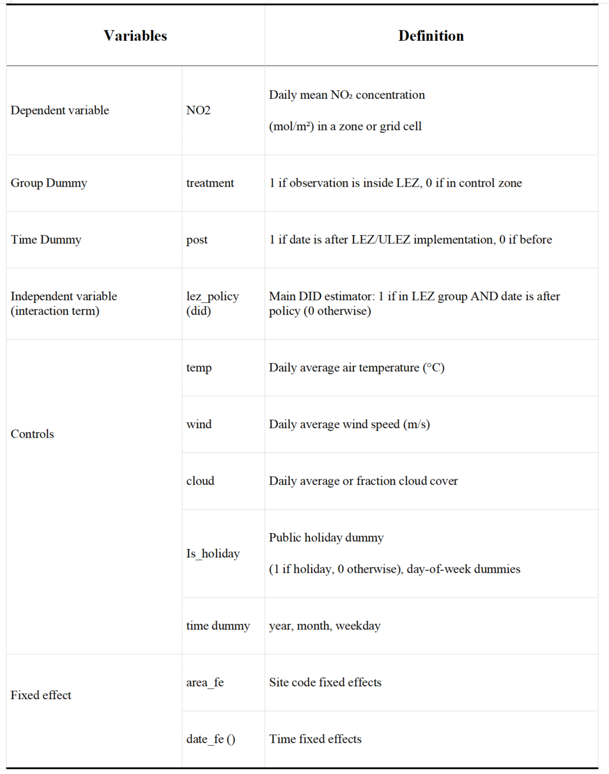

**2) Handle missing values, outliers, and inconsistencies (**[**Code**](#Handle_missing_values)**)**

**3) Problems and solutions**

Access to datasets initially proved difficult, therefore we drew inspiration from preceded studies and decided on the datasets mentioned above. Missing data in Google Earth Engine impeded our progress. In the early stages of our research, we used demeaned ln NO2 in the regression and found the pollutant had increased after the policy’s implementation. This was solved by using ln NO2 in regression.

#### b-2 Data aggregation

Shown in table 2.

#### b-3 Data merging

**1) Merging bands in GEE (JavaScript) (**[**code**](#Merging_Bands_in_GEE)**)**

**2) Merging site type in Stata 17 (**[**code**](#Merging_sitetype_in_Stata_17_code)**)**

**3) Validate merge success and identify any data loss (see screenshot)**

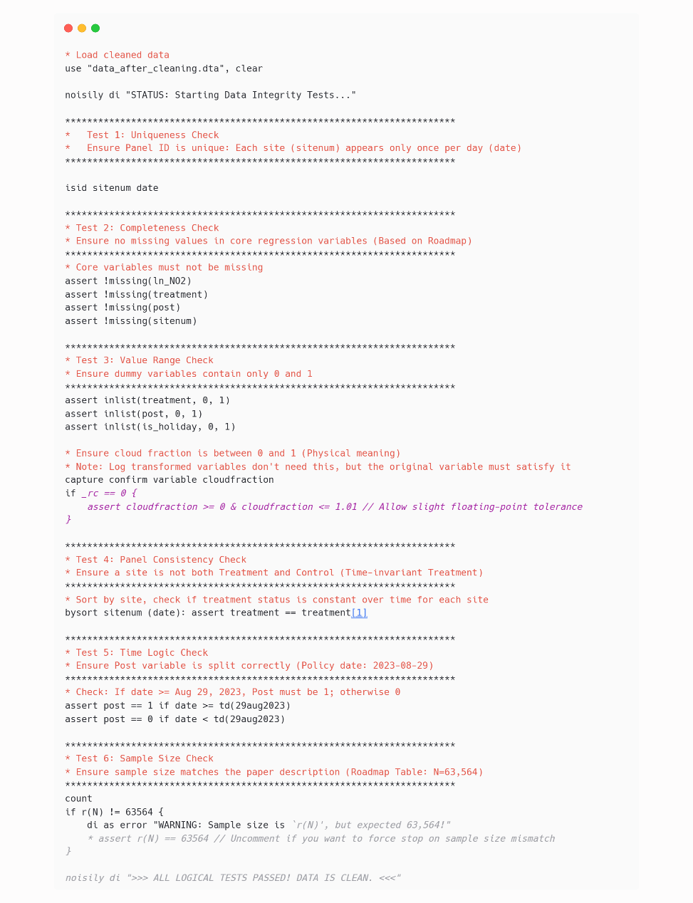

#### b-4 Variable transformation

**1)** **Apply appropriate transformations (**[**code**](#Apply_appropriate_transformations_Code)**)**

We used a natural logarithmic transformation on the dependent variable (NO2 concentration). This is primarily based on the following statistical considerations:

Air pollutant concentration data typically exhibits a right-skewed distribution (log-normal distribution). Direct use of this data can lead to regression residuals that do not satisfy the normality assumption. Logarithmic transformation helps to make the data distribution closer to a normal distribution.

Moreover, environmental data often exhibits a phenomenon where the higher the mean, the greater the variance. Logarithmic transformation can effectively stabilize variance and improve the effectiveness of the estimator.

## 3. Part III: Descriptive Analysis and Export of Results for Presentation

### a. Summary Statistics Table

|  |
| --- |
| **Table 1. descriptive statistics (**[**code**](#Table1_descriptive_statistics_code)**)** |
| carbon (23) |
|  |
| **Table 2: Descriptive Statistics by Site Type (see screenshot)**carbon (24) |
|  |
|  |

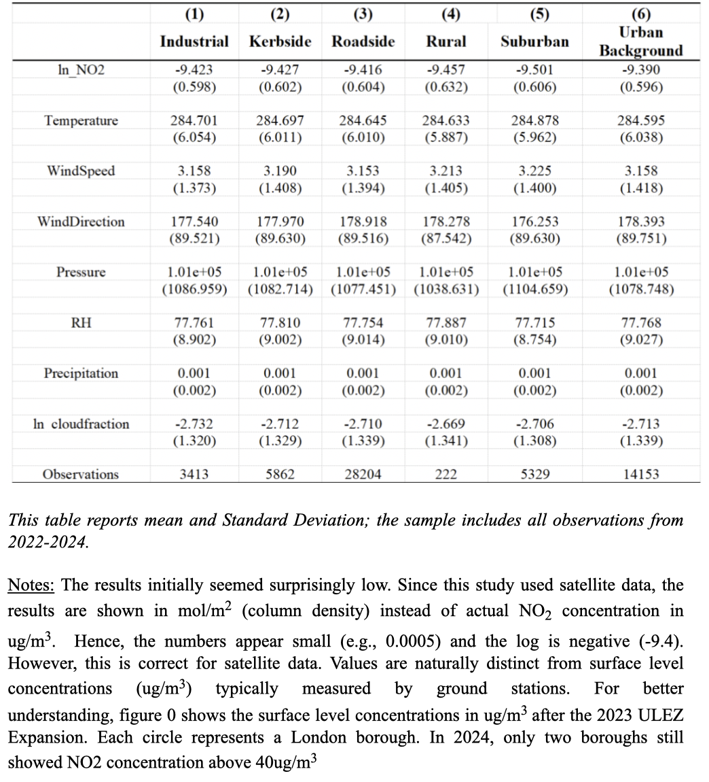

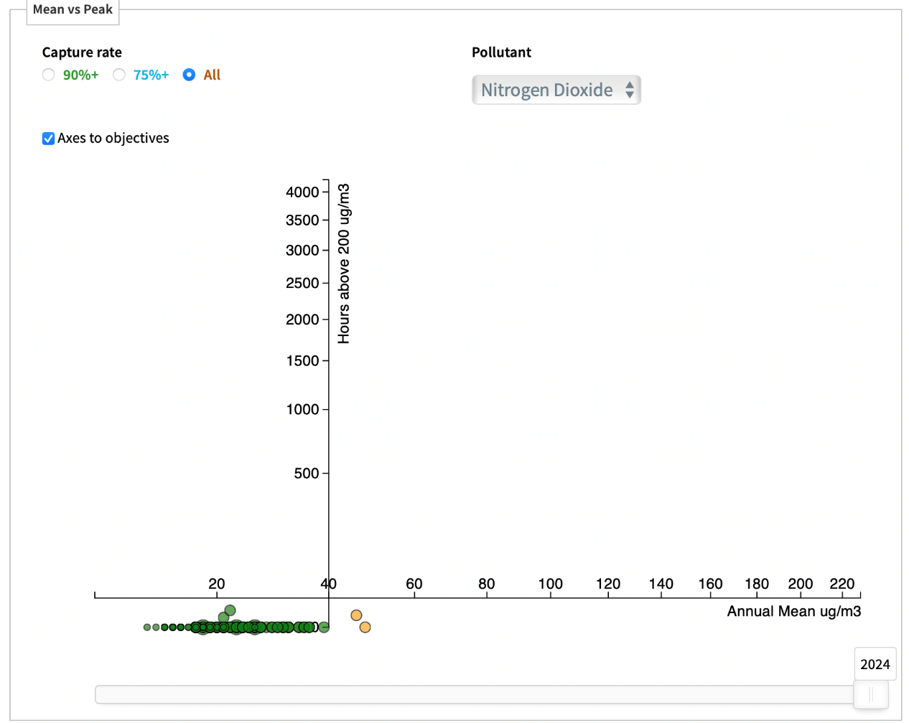

Figure 0. Monitoring Site Visualisation (screenshot taken from <https://www.londonair.org.uk/LondonAir/Data-Visualisations/meanVSpeak.aspx>)

### b. Data Visualization and Exploration

#### b-1 Distribution analysis

|  |
| --- |
| IMG_256 |
|  |
| 图表, 直方图  AI 生成的内容可能不正确。 |
|  |

#### b-2 Temporal and spatial patterns

|  |
| --- |
| IMG_256 |
|  |

图片包含 图形用户界面

AI 生成的内容可能不正确。

|  |
| --- |
| IMG_256 |
|  |
|  |
|  |
|  |

#### b-3 Comparative analysis

|  |  |
| --- | --- |
| IMG_256 | IMG_256 |
|  |  |
|  |  |
| Ein Bild, das Text, Diagramm, Reihe, Schrift enthält.  KI-generierte Inhalte können fehlerhaft sein. | |

#### b-4 Geospatial visualization: Ein Bild, das Text, Screenshot, Schrift, Zahl enthält. KI-generierte Inhalte können fehlerhaft sein.

|  |
| --- |
|  |
| **Example image 1** |

|  |  |
| --- | --- |
|  |  |
| **Fig 7. Mean NO2 level before ULEZ**  (29th of November 2022 to 29th of August 2023) | **Fig 8. Mean NO2 level after ULEZ**  (29th August 2023 to 29th of May 2024) |

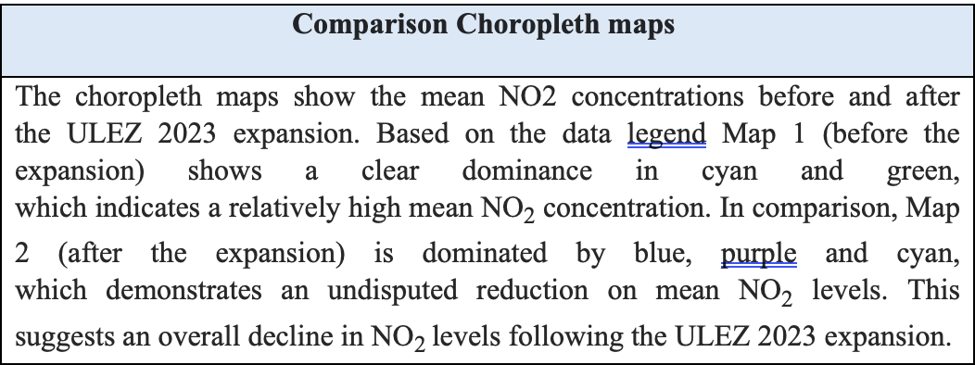

|  |
| --- |
|  |
|  |

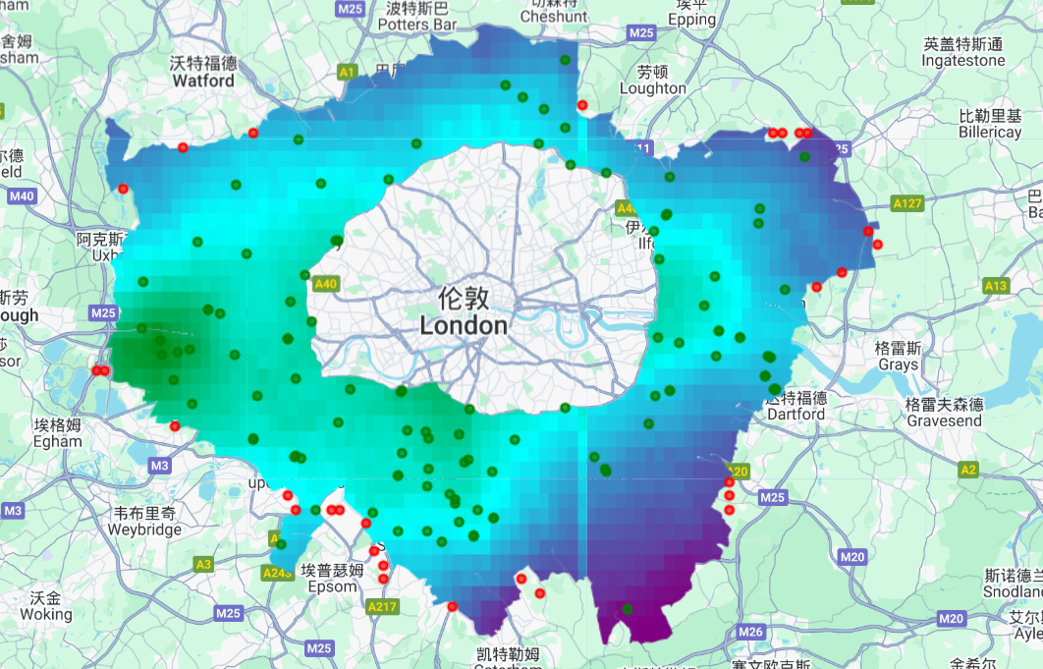

**Fig 9. Location of Sample group and Control Group**

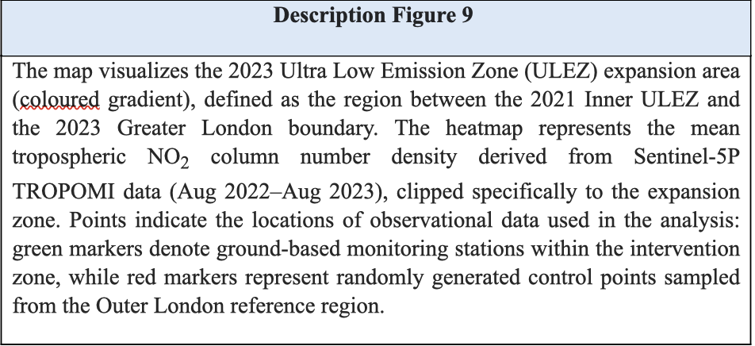

### C. Introductory Regression Analysis

#### C-1 Event Study

**Code (Stata)**

|  |
| --- |
|  |

([code](#Figure11_code))

Ein Bild, das Text, Screenshot, Schrift, Zahl enthält.

#### C-2 Regression Analysis



|  |  |
| --- | --- |
|  |  |

|  |
| --- |
| **Table 3: DID Estimates and Heterogeneity by Site Type** |
|  |

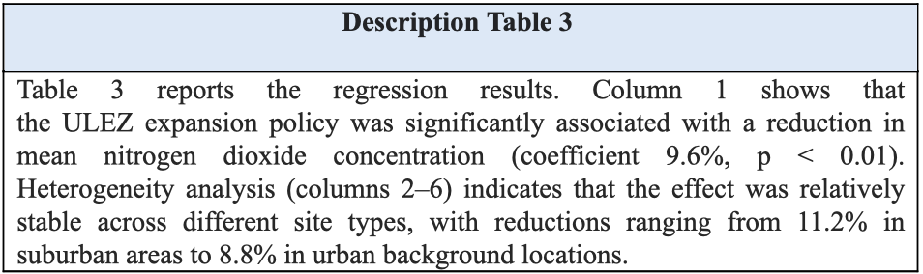

#### C-3 Placebo Test: Permutation-based Methods

|  |
| --- |
| IMG_276 |
| Figure 11. Result [(code)](#Figure9) |

#### C-4 limitations and caveats of findings

Several limitations should be considered when interpreting this analysis’ results. First, the ULEZ coincides with other policies, industry actions, and behavioural patterns which aggravates isolating its effects. Additionally, as mentioned above, certain variables have been controlled to facilitate the analysis. The observed changes in NO2 can therefore not solely be attributed to the ULEZ. Second, detecting untreated control groups that provide data originating from similar sources to the treatment group proves difficult. The control groups in this analysis are located near the ULEZ, increasing the likelihood of spillover effects. It should also be noted that the control groups were randomly selected and could possibly be exposed to different socio-economic conditions than the treatment group. Third, the data is limited to specific monitoring sites, the results therefore provide only a limited depiction.

#### C-5 Connect results back to environmental economics theory

Our analysis shows that there has been a reduction in NO2 concentration since the implementation of the 2nd ULEZ expansion, which proves the policy’s success. Additionally, we observe a spillover effect on adjacent areas, especially roadsides and suburban sites. This effect could potentially play into the pollution haven theory in the long term, causing industry changes within the UK and further reducing its emissions. The policy has evidently shifted behavioural patterns, as the marginal private cost increased due to the daily charge for non-compliance. Simultaneously, the private abatement cost reduced, especially for people living near public transport, as the cost of public transport is significantly lower than the accumulated cost of driving into London’s ULEZ. The daily charge increased marginal private cost towards social optimum, therefore effectively mitigating further pollution. Consistent with environmental economics, the policy’s success suggests an increase in social welfare, as marginal damage (environmental harm and health) has decreased. The results provide empirical evidence for the effectiveness of environmental policies.

## 4. Part IV: Discussion and Conclusions

### a. Key Findings Summary

This study examines the effects of the Ultra Low Emission Zone (ULEZ) Policy which was initially introduced in London in October 2019 and expanded in August 2023. For this purpose, satellite-based data was used to analyse the changes in NO2 concentration eleven months before and after the 2023 ULEZ expansion. We examined the mean NO2 concentration broken down by weeks and found that there has been a trend in NO2 concentrations decreasing since the ULEZ 2023 expansion. As depicted in figure 2, this therefore answers research question 1, the NO2 concentration has decreased between 2022 and 2024. To identify whether this change in NO2 emissions is due to the Policy or simply coincidental, we performed a DID Regression analysis. Column one of table 3 proves that the decrease in NO2 concentration was significantly influenced by the policy since its introduction, which therefore answers research questions 2. Columns two until six show that the NO2 reduction is relatively stable, although suburban areas recorded the biggest change with 11.2 percent.

### b. Policy and Research Implications

The findings indicate that the ULEZ expansion 2023 can be directly associated with a reduction in mean NO2 levels within the affected areas of London, which suggests that environmentally targeted policies concerning transportation can lead to improvements. Additionally, these policies are more impactful than initially expected, as the spatial patterns reveal a spillover to adjacent areas. Policy makers could therefore consider introducing ULEZ policies to broader areas and cooperating with adjacent areas.

Regarding the chosen method of analysis as well as the limited time window given to examine the changes in NO2 concentration since the policy’s introduction, future research should focus on long-term effects as well as incorporation of the controlled variables.

### c. Technical Reflection

Our analytical approach allowed us to work with precise data, the use of Stata on the other hand made sure for our process to be reproducible. To reproduce the results, the *master.do file* located in the home directory acts as the controller. This file includes the clean up, merge, and regression to create all the tables and figures displayed in this report.

Strengths of our analytical approach  
  
We used Difference-in-Differences (DID) model, and it is supported by an event study. The analysis confirmed the "parallel trend hypothesis," which means treated and control groups had similar air quality changes before the policy implementation.

Limitations of our analytical approach  
  
The analysis is constrained by a relatively short time window (eleven months before and after the expansion). Therefore, long-term effects cannot be fully assessed.

Challenges encountered in data preparation and solutions developed

**Problem 1:** It was difficult to identify exactly which geographical areas were part of the 2023 ULEZ expansion and to match them with NO2 emission datasets.

Solution: We used Google Earth Engine to visualize the boundaries. 5 layers were applied (including the Outer London Control Area, 2023 Expansion Zone, and London Boundary) to visually distinguish the control areas from the treated areas.

**Problem 2:** The raw satellite data required significant pre-processing before importing in Stata.

Solution: We used GEE for pre-processing, visualizing mean NO2 levels, and merging bands (using JavaScript).

## Bibliography

Boogard, H. et al. (2022) ‘Long-term exposure to traffic-related air pollution and selected health outcomes: A systematic review and meta-analysis', *Environment International*, 164 (2022), <https://doi.org/10.1016/j.envint.2022.107262>

Field, B.C., and Field, M.K. (2020) ‘*Environmental Economics: An Introduction*. New York: MacGraw Hill LLC

Gregg, D.J. *et al.* (2026) ‘The impacts of the Ultra Low Emission Zone (ULEZ) and COVID-19 restrictions on air quality in central London – evidence for an increase in small particles’, *Atmospheric Environment*, 365(2026), <https://doi.org/10.1016/j.atmosenv.2025.121668>

Hajmohammadi, H. and Heydecker, B. (2022) ‘Evaluation of air quality effects of the London ultra-low emission zone by state-space modelling’,*Atmospheric Pollution Research*, 13(8), <https://doi.org/10.1016/j.apr.2022.101514>

Ma, L., Graham, D.J., and Stettler, M.E.J. (2021) ‘Has the ultra low emission zone in London improved air quality?’, *Environmental Research Letters*, 16 (21), <https://doi.org/10.1016/j.atmosenv.2025.121668>

Prieto-Rodriguez, J. *et al*. (2022) ‘Impact of London Toxicity Charge and Ultra Low Emission Zone on NO2’, *Transport Policy*, 129(2022), <https://doi.org/10.1016/j.tranpol.2022.10.010>

London Assembly (2019) *World’s first 24 hour Ultra Low Emission Zone starts in London*. <https://www.london.gov.uk/press-releases/mayoral/ulez-launches-in-central-london> (Accessed: December 10, 2025)

Tong, C. *et al*. (2025) ‘Further improvement in London’s airquality demands more than the Ultra Low Emission Zone policy’, npj clean air, 1(29), <https://doi.org/10.1038/s44407-025-00030-9>

Verbeek, T. and Hincks, S. (2022) ‘The ‘just’ management of urban air pollution? A geospatial analysis of low emission zones in Brussels and London, *Applied Geography*, 140 (2022), <https://doi.org/10.1016/j.apgeog.2022.102642>

## Appendix

|  |
| --- |
| **Handle missing values, outliers, and inconsistencies (**[**back**](#Handle_missing_values_Text)**)** |
| ~~carbon~~ |

|  |  |
| --- | --- |
| **Merging Bands in GEE (**[**back**](#Merging_Bands_in_GEE_Text)**)** | |
|  |  |

|  |
| --- |
| **Merging site type in Stata 17 (**[**back**](#Merging_sitetype_in_Stata_17)**)** |
|  |

|  |
| --- |
| **Apply appropriate transformations (**[**back**](#Apply_appropriate_transformations_Text)**)** |
|  |
|  |

|  |
| --- |
|  |

|  |  |
| --- | --- |
| **Fig 11. Event Study (**[**back**](#Figure11)**)** |  |
| IMG_256 | IMG_256 |

| **Figure 12. Placebo (**[**back**](#Figure9_text)**)** | |
| --- | --- |
| carbon (14) | carbon (14) |